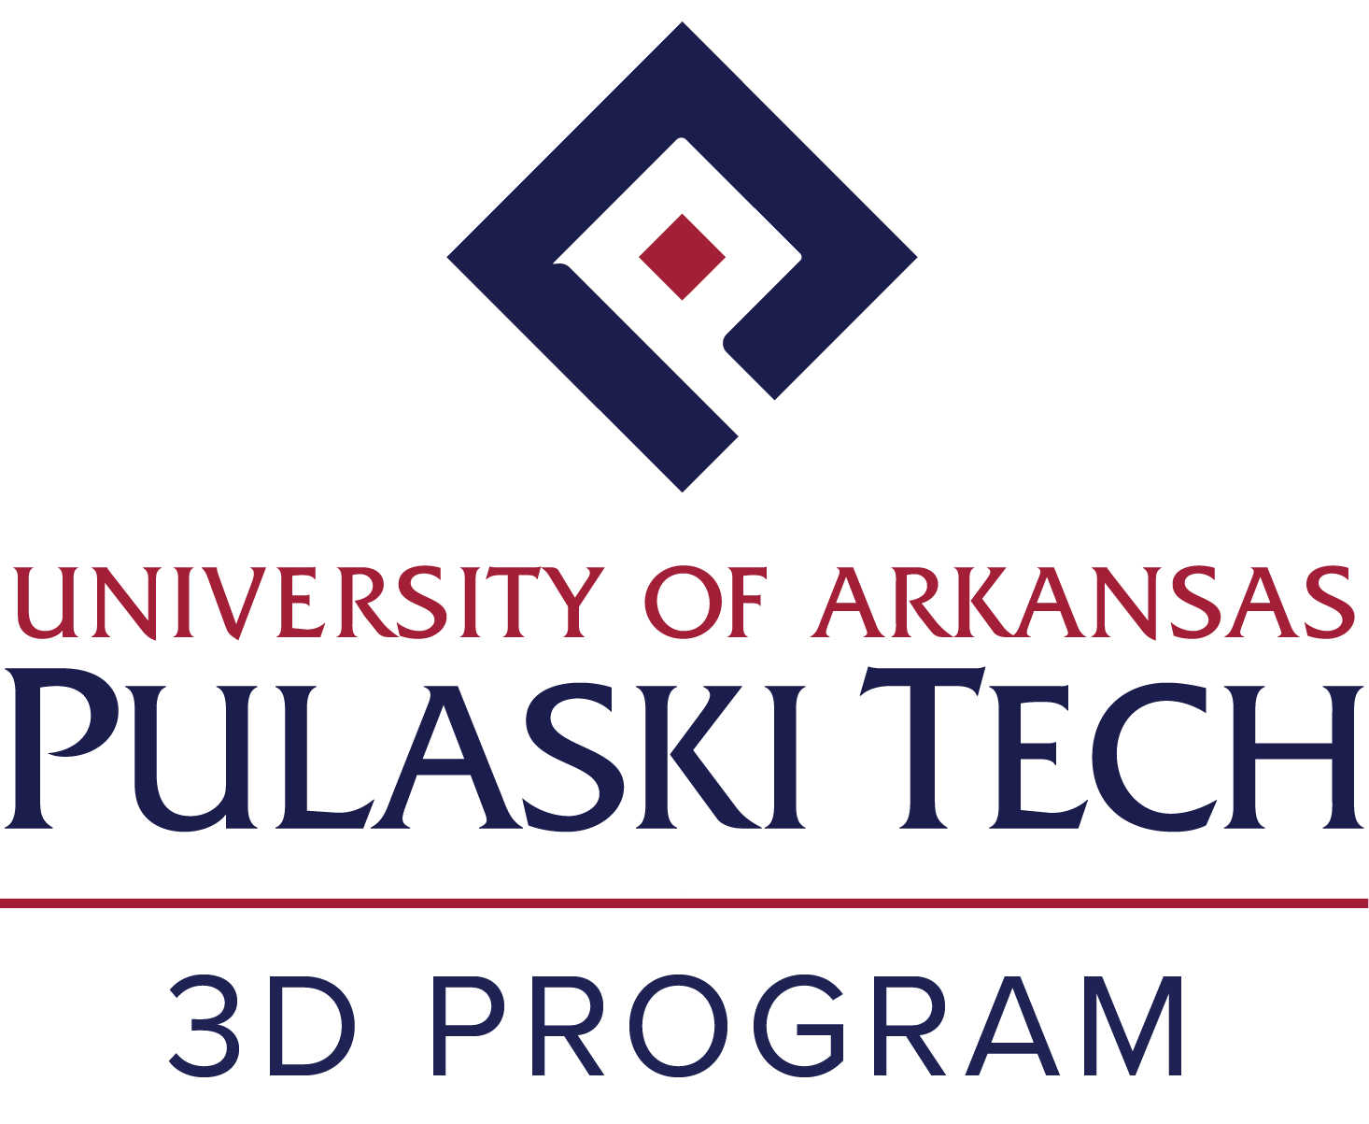

Student Handbook

Last revised 1/14/2026
Table of Contents

Mission, Vision, and Contact Information……………………………………………………………………. 3
3D Program Information………………………………………………………………………………………. 5
- Learning Outcomes………………………………………………………………………………….…. 5
- Courses and Course Credits…………………………………………………………………………… 6
Acceptance and Enrollment Information………………………………………………………………………7
- Checklist………………………………………………………………………………………………… 7
- Supplies………………………………………………………………………………………………….. 7
- Uniform………………………………………………………………………………………………….. 7
Tuition and Scholarships……………………………………………………………………………………….. 8
Academic and Personal Development Plan Information…………………………………………………….. 8
Future Registrations.………………………………………………………………………………………….. 11
UA-PTC and CAHMI Attendance Policy……………………………………………………………………. 11
Course, Classroom, and Lab Policies………………………………………………………………………… 11
Student Uniform and Dress Code……………………………………………………………………………. 13
Professional and Safety Standard Requirements…………………………………………………………… 15
Policies for Non-Compliance…………………………………………………………………………………. 15
Code of Conduct / Catalog Information……………………………………………………………………... 16
Complaints, Concerns, and Grievances……………………………………………………………………… 16
Family / Support Involvement and Expectations…………………………………………………………… 17
FERPA………………………………………………………………………………………………………… 19
Student Services Directory and Information………………………………………………………………... 20
Student Responsibility Statement……………………………………………………………………………. 24

3D Program Student Handbook
Mission
Our mission is to provide access to high-quality education that promotes student learning and enables individuals with disabilities to reach their fullest potential through unique, targeted programs for business and industry.
Vision
Our vision is to be a leading educational program, focused on student success and recognized for excellence in education and workforce development for individuals with intellectual and/or developmental disabilities (IDD).
How to use this handbook
We’ve put together this handbook with you in mind. It is your guidebook for getting familiarized with UA-Pulaski Technical College and the 3D Program. Inside, you will find details about your academic journey and resources you may need along the way. Take your time going through each section of this handbook. It’s a great way to get a clear picture of what’s ahead and what’s expected of you as a student in the 3D Program at UA-PTC. We hope you use this book to help you understand your rights, responsibilities, and navigate this exciting phase of your education.

College Contact Information
Mailing Address: Email: 3d@uaptc.edu
3D Program Website: https://uaptc.edu/3D
UA-PTC Little Rock-South
13000 Interstate 30
Little Rock, AR 72210
Phone: (501) 812-2709
Fax: (501) 812-2316
UA–PTC Hours & Contact Information
UA–PTC campuses are open Monday through Friday, 8:00 a.m.–4:30 p.m., unless otherwise noted on our website homepage. We’re happy to assist you during regular business hours.
Please note that our culinary, baking, and hospitality faculty are often teaching in classrooms and labs Monday through Thursday and are available on Fridays by appointment only. If you need to reach them, the best option is to call the office number or send an email. Both can be found in our online directory. Be sure to leave a message, and they will return your call as soon as they are available.

People to Know in the Culinary Arts and Hospitality Management Institute:
Jan Lewandowski Dr. Robert Hall
Executive Director of CAHMI Lead Teaching Professor of Culinary
jlewandowski@uaptc.edu rhall@uaptc.edu
(501) 812-2744 (501) 812-6056
Dr. Mary Catherine Miller Bernadette Hubbard
3D Program Director Assistant Teaching Professor of Culinary 3D Program
mmiller@uaptc.edu bhubbard@uaptc.edu
(501) 812-2723 (501) 771-6061
Kimberlie Jeffers Catherine McCormack
Assistant Teaching Professor Assistant Teaching Professor of Baking and Pastry Arts
kjeffers@uaptc.edu cmccormack@uaptc.edu
(501) 812-2742 (501) 812-6054

Other Important Resources/Contact Information:
UA-PTC Billing and Student Accounts: UA-PTC Financial Aid:
studentbilling@uaptc.edu finaid@uaptc.edu
501-812-2278 501-812-2289
UA-PTC Campus Police: UA-PTC Dean of Student Life and Wellness:
police@uaptc.edu Michelle Anderson
501-812-2711 manderson@uaptc.edu
501-812-2756

Arkansas Rehabilitation Services: AEDD Support Services and
Toll Free: 1-800-330-0632 Transportation Information:
501-296-1600 Deborah Smith
ARS.communications@arkansas.gov dsmith@aeddinc.org
For Local Office Contact Information: 501-562-6579
https://dws.arkansas.gov/ar-rehabilitation-services/contact-ars/

ModivCare (Non-Emergency Transportation):
https://www.mymodivcare.com/members/ar/#contact
https://www.mymodivcare.com/contact-us/

UA-PTC 3D Program
The University of Arkansas - Pulaski Technical College’s 3D Program offers young adults with intellectual and/or developmental disabilities (IDD) post-secondary education and preparation for employment through its certificate programs. The 3D program promotes and assists in life skill and technical skill development in the areas of culinary arts, hospitality, and baking. It is a post-high school program.
The 3D Program was established in 2013 as an inclusive post-secondary education program for individuals with disabilities. The three-year program seeks to provide students with academic rigor, socialization, independent living skills, self-advocacy skills, and preparation for gainful employment. Students participate in 3D classes as well as inclusive classes with other students enrolled in the UA-PTC’s Culinary Arts and Hospitality Management Institute's many programs. In these classes, 3D students will work alongside peers who provide natural supports in the classroom. Our inclusive courses are taught by certified chef instructors.

Learning Outcomes
The Culinary Department, consistent with the College’s mission and the Division’s objectives, encourages the success of its students in all technical fields and academic disciples by promoting:
- Establish and maintain high standards of sanitation and food safety as established by the SERV SAFE® program.
- Demonstrate proficiency in basic terminology and techniques for culinary arts and baking and pastry arts to include food preparation, presentation, and service.
- Identify and demonstrate the concepts of recipe costing, purchasing, receiving, and issuing practices in food service operations.
- Explain the characteristics, functions, and food sources of the major nutrients and understand and demonstrate nutritional cooking methods including how to maximize nutrient retention.
- Communicate clearly and professionally, both verbally and in writing.
- Develop strategies to improve business performance using creativity and problem-solving skills, based on operational theory and procedures.
- Develop skills integral to success in the industry including guest service, supervisory management, the ability to work with others, and handling multiple tasks simultaneously.
- Develop and apply ethical and sustainable hospitality industry policies.

3D Program Outcomes:
- Outcome 1: Students will demonstrate growth in independent living skills.
- Outcome 2: Students will participate in an academically enriched environment.
- Outcome 3: Students will be active members of the college campus.
- Outcome 4: Students will gain experience leading to competitive employment.

Concentration: Culinary Arts:
- Identify principles of menu and food service facility layout and design.
- Understand where food comes from, differences in growing practices and how to prepare a seasonal menu.
- Demonstrate and discuss the differences in cuisines and ingredients used around the world.
- Prepare regional, international, and classical cuisine dishes and demonstrate an understanding of how they are utilized in the contemporary food service industry.
- Develop skills integral to success in the food industry including speed, stamina, dexterity, and timing.

Concentration: Baking & Pastry Arts:
- Demonstrate professionalism and sanitation practices as well as mise en place, organization, sense of urgency, and timing in a professional kitchen.
- Demonstrate knife skills, hand tools, and equipment operation, emphasizing proper safety techniques. Identify and demonstrate knowledge and proper selection of equipment and utensils for specific baking applications.
- Utilize standard weights and measures to demonstrate proper scaling and measurement techniques.
- Define baking terms and identify and describe properties of ingredients and products, and demonstrate utilization of these products.
- Calculate a recipe conversion factor to make a desired quantity of a given recipe and compute the new ingredient quantities using the recipe conversion factor.
- Discuss recipe modification to create more nutritionally beneficial baked goods and desserts.

Concentration: Hospitality Management:
- Demonstrate critical and creative thinking.
- Recognize and understand cultural and individual differences, in terms of both contemporary and historical perspectives.
- Recognize and understand social, political, civic, and environmental responsibilities related to our society.
- Apply basic scientific concepts in a variety of settings
- Communicate effectively in written, oral, and symbolic forms
- Exhibit quantitative literacy
- Apply ethical reasoning
- Demonstrate the acquisition and use of information

Courses and Course Credits
- Students spend the first semester in 3D-only classes where they learn the basic skills needed to participate in inclusive course experiences. The following 3D core classes are required of all students:
  - Intro to CAHMI
  - 3D Sanitation
  - Professional Conduct
  - Independent Living Skills
  - Intro to Financial Literacy
  - Hospitality Fundamentals
- In semesters 2-6, students will participate in inclusive classes. The following inclusive course experiences are required for all 4 certificate options:
  - Food Production 1
  - Baking 1
  - Health Food and Nutrition
  - Introduction to Hospitality
  - Product Identification and Quantity Food Purchasing
  - Professional Beverage and Wine Studies
- All 3D students will complete 4 different internship experiences. Internship 1 and Internship 2 are internal internships in which the student will be placed into an internship on campus. Hospitality Practicum, Baking Practicum, and Culinary Practicum are practicum experiences with external employers in which the student will work outside of the college and receive on-the-job training.
You’ve Been Accepted and Enrolled! Now what?

Checklist:

Complete and submit a FAFSA (School Code: 014167)

Complete and submit the Governor's Higher Education Transition Scholarship

Secure an Arkansas Rehabilitation Services Counselor

Create a Student Workday Account

Complete Workday Onboarding Tasks

Secure Transportation services (if applicable)

Attend New Student Orientation (August)

Students can access step-by-step instructions for creating a Student Workday account and completing their onboarding tasks here: https://uaptc.edu/student-workday

What items do I need to start the program?

Students are required to supply the following items:

A binder or notebook for class notes/instructions

Black, non-skid shoes (kitchen safe shoes)

Black socks

A flash drive

White t-shirts to wear under chef coats

Pens and Sharpies for uniform

The following items will be provided to students:

A knife kit

3 or 4 chef coats for first-year students and 1 new chef coat for second and third-year students

3 or 4 chef's pants for first-year students and new pants for second and third-year students if needed

Books to check out for classes (when applicable)

Hats or caps for first-year students and as needed for second and third-year students

Getting Fitted for Your Uniforms
- Get fitted for uniforms at CAHMI office on the second floor of the Culinary Arts and Hospitality Management Institute building.
- Once your correct size is assessed, your chef coats, pants, and hats will be ordered for you.
- Your uniforms should be ready for you to pick up on your first day of class. Please see the 3D Program Director to pick those up.
- If you need additional uniforms or need to swap out sizes, please contact the 3D Program Director.
- Shoes: It is the responsibility of the student to purchase non-skid, kitchen-safe shoes. Students should maintain and replace their shoes when necessary.

Tuition and Scholarships
The 3D Program is tuition-based and is a Comprehensive Transition and Postsecondary program (CTP) approved by the U.S. Department of Education. Funding is available through a variety of sources, including grants, scholarships, and the Federal Pell Grant, as well as Federal Work Study positions.
- Governor’s Higher Education Transition Scholarship (GHETS)​
Apply online- deadlines July 1 for Fall and January 10 for Spring.
https://sams.adhe.edu/Scholarship/Details/GHETS ​
  - Once your student has accepted the scholarship, they are automatically awarded for the following semesters. This is an 8-semester scholarship.
- FASFA- complete application at https://studentaid.gov/h/apply-for-aid/fafsa ​
UA - Pulaski Tech's FAFSA School Code is 014167​
- ​Arkansas Rehab Services provides tuition funding for students- reach out to your counselor. https://dws.arkansas.gov/ar-rehabilitation-services/ ​
- ​ VA Funding: Contact James Boski, UA-PTC VA Coordinator at (501) 812-6028​ / jboski@uaptc.edu
- Privately funded scholarship monies may be available at https://uaptc.edu/foundation/scholarships

Check your Financial Aid Awards on Workday:
STEP 1: After completing the Admissions Process and being accepted, check the Financial Aid Hub in your Workday account and begin checking your student email.
STEP 2: In 3 - 5 days after applying for Federal Aid, check your email for instructions on your next steps.
STEP 3: Through the Financial Aid Hub, review the DOCUMENTS tab and complete and submit any required documents.
STEP 4: Monitor your student email for an award notice and complete your online award letter through the Financial Aid Hub.
STEP 5: Keep your aid by maintaining Satisfactory Academic Progress.

Academic and Personal Development Plan
During the first semester and every semester following, the 3D Director and Faculty will create an ongoing academic and personal development plan that is specific to each student enrolled. A student’s Academic and Personal Development Plan (APDP) is their road map to college success. It outlines classes and career goals, action steps, accommodations and/or modifications for academic success, support strategies from faculty and staff, and a final semester assessment. The students, 3D Program Director, and 3D Faculty will spend time each semester updating and reviewing Academic and Personal Development Plans. An example of that plan can be seen on the following page.

Student Academic and Personal Development Plan
Student: | Semester: |  | Date:
Academic Degree Program:
Department/Division:  3D Program / Culinary Arts and Hospitality Management Institute |  |  | College: UA – Pulaski Technical College
Mission of the Program
The mission of the 3D Program is to provide access to high-quality education that promotes student learning and enables individuals with disabilities to reach their fullest potential through unique, targeted programs for business and industry.
Goals
A goal is a general statement about the aims or purposes of the educational experience, including short and long-range outcomes.
Goal 1:
Goal 2:
Goal 3:
My Action Steps
Describe the steps you will take to reach your goals.
How Will I Show My Learning or Progress?
Accommodations/Modifications for Academic Success / Support Strategies
How Faculty Will Support Student to Meet Their Goals
Semester Assessment
Courses | Instructor | Grade
Career/Employment:
Socialization/Co-Curricular Activities:
Independent Living:

Future Registrations

Students who continue in the program will be automatically enrolled in classes each semester. Course selections are based on the student’s major and individual goals. Students may change their major at any time by meeting with the 3D Program Director. They are also encouraged to meet with the Director to discuss current courses, future plans, or upcoming semesters.

Students and their families are welcome to schedule a meeting with the 3D Program Director at any time to review class options for the next semester. Parents or guardians may attend these meetings at the student’s request.

All class registrations are done in Workday. Students can access their academic plan anytime in their Student Workday account.

Important College and Department Information

UA-PTC Attendance Policy
The College’s general attendance policy is: https://uaptc.edu/attendance

CAHMI Departmental Attendance Policy
-Students will be required to sign in at the beginning of each class period and to sign out at the end of class as well.
-Each student is expected to arrive on time, attend all scheduled classes and stay for the entire class session.
-It is the responsibility of the student to find out what assignments are given and have them prepared on the due date.
-The student is responsible to get notes and information missed from another student in the class or contact the instructor.
*Excessive tardiness and absences may result in students failing the class. Failing a class or multiple classes will result in subsequent re-enrollment in the class(es) as well as impact GPA and academic progress.

Course, Classroom, and Lab Policies
The UA-PTC Catalog rules and regulations will be enforced in this course at all times. Please consult the following website for more information: https://www.uaptc.edu/catalog
- Professional behavior is required. Punctual attendance and intelligent participation are expected. Particulars as determined by the instructor are detailed in the paragraph below.

- Appropriate behavior is expected for all communications, including any notes, email messages, or telephone conversations.

Student Behavior: Students are expected to behave in the classroom.
- Treat others with respect. Part of the college experience is being exposed to people with ideas, values, and backgrounds different from yours.

- Any behavior that disrupts the class may result in that student being asked to leave the class for the day. Obtain a copy of the student handbook; read the standards of conduct and adhere to them. They will be strictly enforced in this class.
- Be prepared for class. Complete reading assignments before class so that you can understand the lecture and participate in the discussion. Always have a necessary pen or pencil, paper, and pastry or culinary kit.
- Keep your work area clean. Other classes use the same room. It is imperative that you keep up with your books and other class materials.

Cell phones: In consideration of others, cell phones and other personal communication devices must be turned off during class. If there is an EMERGENCY situation and you must be available by phone, inform your instructor and set your phone to a mode that will not disturb others. (E.g. silent or vibrate).

Arriving Late for Class: Students arriving late to class are distracting. If you arrive late, please enter quietly, avoid interrupting the instructor, and wait for a natural break in active instruction/demonstration to obtain missed information.

Children in Class: Students may not bring children to class, and may not leave children unattended anywhere on campus.

Classroom / Lab Safety
Classroom and lab safety is the responsibility of everyone. UA-PTC students must adhere to the following basic standards. Some programs and courses may have additional requirements.

Culinary and Baking Labs:
- Never use a machine without proper training.
- Wear all required protective coverings at all times.
- Return all equipment, tools, and other items to the designated location at the end of the class session.
- Participate in the clean-up process.
- Report injuries, spills, and needed repairs to your faculty member.

Computer Labs:
- With all the electric equipment in the lab classroom, students are not allowed to have food or drink anywhere in the equipment room. Check with your instructor to see if there is a place where drinks may be left and retrieved after class.
- Lab computers are to facilitate student learning, not for “surfing the net” or playing games unrelated to the course. Students will not use the internet and its technologies (e.g. check e-mail, participate in “chat sessions”, browse the web, etc.) during class unless the instructor requests that you activate these technologies for class lecture demonstrations or class work.
- All equipment items (and supplies for them) are property of the state of Arkansas and are to be treated with care. Equipment and supplies are not to be removed from the lab.
- Use of computer equipment is for the class meeting in the lab at the scheduled time. Any student who needs to use equipment (creating, editing, or printing) while a class is meeting must obtain permission from the instructor in advance; such permission must be obtained without interruption of the lecture/demonstration.

Dress Code for the Culinary Arts and Hospitality Management Institute (CAHMI):
All students of the CAHMI program are expected to maintain the highest standards of personal hygiene and to present a professional appearance at all times. Students are required to dress in the standard uniforms any time you are in the building or when attending off-site visits to industry-related businesses. All uniforms must be clean, pressed and in good repair. Uniforms should be buttoned up correctly and worn with pride.
Culinary & Baking Lab Uniform:
- Official White PTC Chef Coat- black or white under shirt; no visible logos should be visible under coat.
- Black Chef’s Pants or loose-fitting black pants, hemmed above natural heel and below the ankle – no denim, yoga pants, leggings, or other tight-fitting pants
- Solid Black, Non-slip Shoes (clean and sturdy—no tennis shoes!)
- UAPTC black ball cap, UAPTC CAHMI Chef hat or hairnet
- Black Sharpie, Ink pen, Thermometer worn on sleeve

Hospitality Uniform:
- PTC Polo, Royal Blue or Black (available in the Bookstore)
- Black Slacks, Black Belt, Black Socks, Black Shoes (skid resistant)
- (or)Black Skirt (knee length), Black Stockings or Black Socks
  - OR
- Student’s work/business attire

Hospitality Students must wear proper shoes for kitchen passage. You are not generally in the kitchen, but you may have to pass through the kitchen to retrieve equipment or supplies.

Additional Materials
For Lab Classes, each student is required to bring to class each day the following:
- Knife Kit (knives must be sharpened before each class)
OR
- Baking Kit - no rolling tool carts in the lab

It is the responsibility of each student to take care of their kits and keep up with all their knives and tools. The Pulaski Technical College Culinary Arts and Hospitality Management Institute assumes no responsibility for lost or stolen items.

Each student should come to class with a black permanent marker used for labeling, paper, and a writing instrument to take notes, tests, etc. Taking notes is essential as the information that will be given may not be available in the text. It is suggested that you bring a calculator.

Additional reminders:
- Chef coats should be removed when leaving the CAHMI building and should not be worn recreationally outside of the classroom.
- Aprons and hats are not required during lecture classes.
- Aprons and towels should be left in your class anytime you exit the kitchen/bakeshop

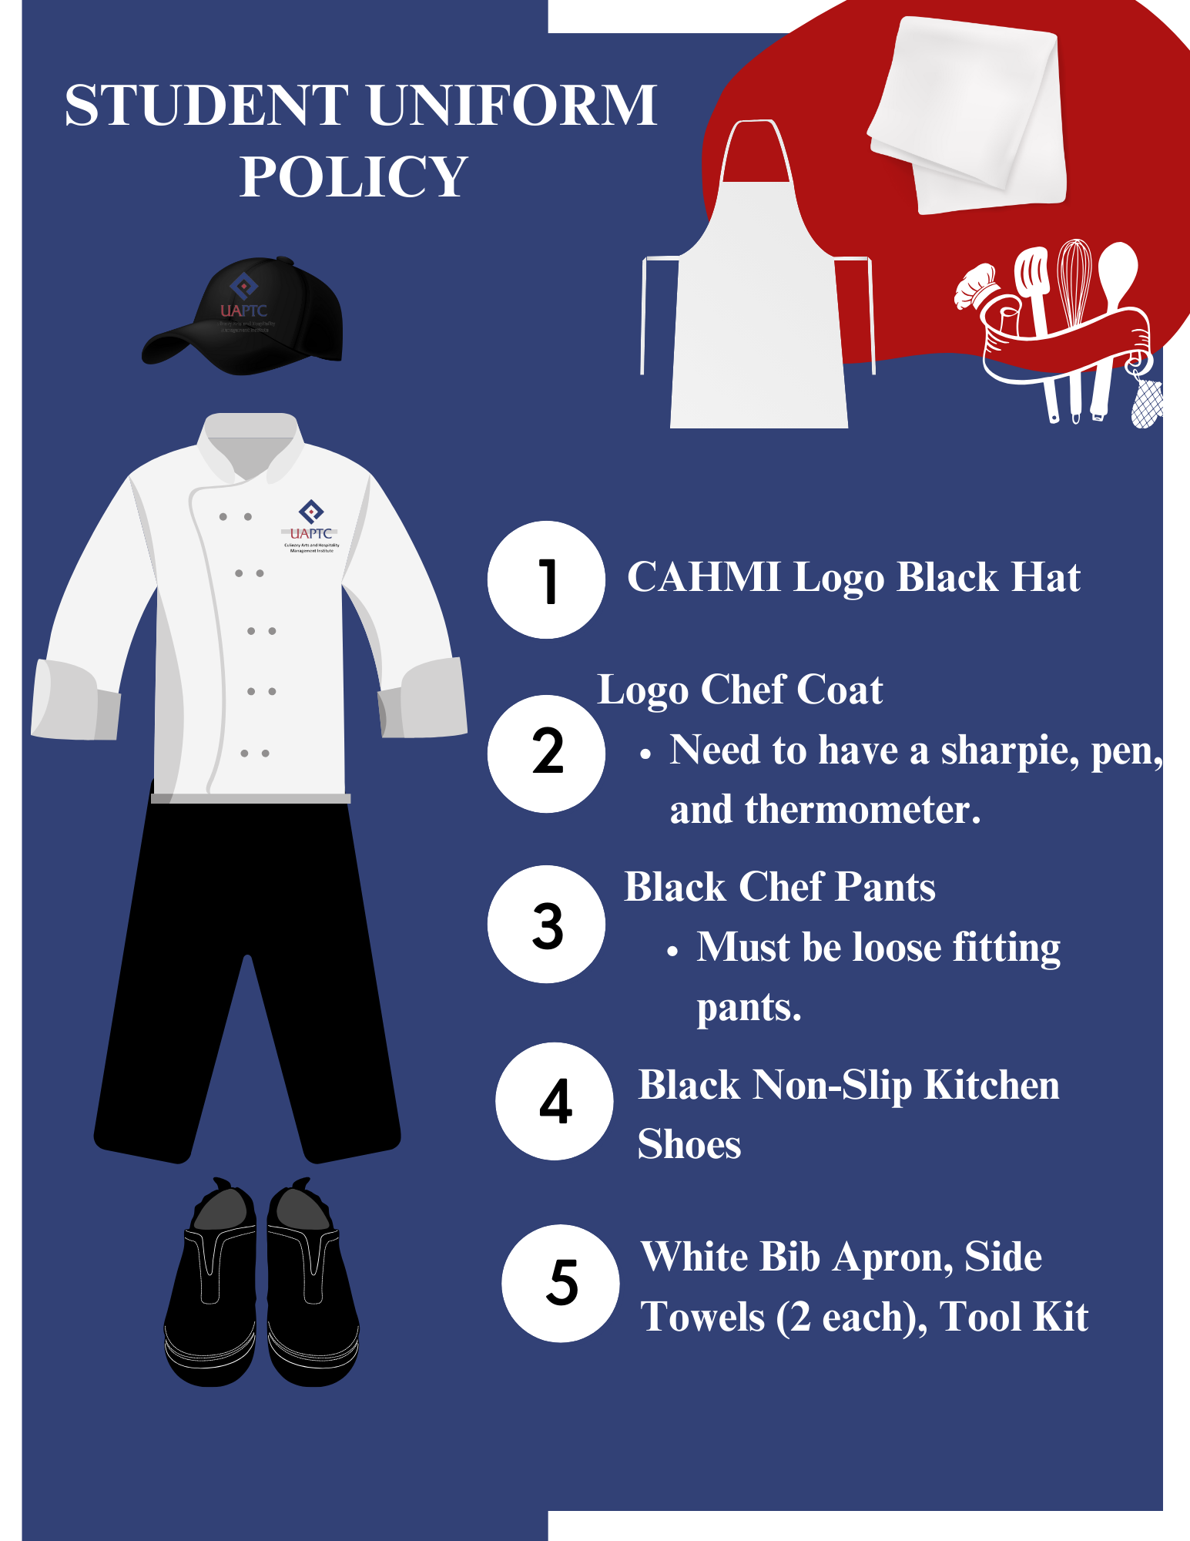

Professional and Safety Standard Requirements
- It is the responsibility of all foodservice professionals to bathe or shower, practice oral hygiene, and use deodorant daily.
- Hair should not fall below the neckline or be in the face and must be neatly secured and restrained properly when pulled back underneath a hat or hairnet.
- Men must be clean-shaven or have neatly trimmed beard and mustaches when in lab classes. If facial hair is worn, regardless of length, a beard guard is required.
- Nails should be neatly trimmed, clean, and free of fingernail polish.
- One plain ring is allowed- no other jewelry is permitted.
- No piercings of any kind; please remove or cover these up before entering the lab or classroom. Facial jewelry that cannot be removed for medical or other reasons should be covered up or clear inserts can be used.
- No excessive cologne, aftershave, sprays, lotions, or other odors. Students displaying strong odors such as these as well as odors such as cigarette smoke may be asked to leave the classroom.
- Outerwear (coats, hoodies, and sweatshirts) may not be worn in kitchens and should be stored in lockers or left in vehicle.
- Headphones, earbuds, or other electronic devices are not allowed in class. Cell phones should be stored out of sight during production and used only with permission.
- Eating and drinking (from a closed container) is allowed only in designated areas and away from the workstation.

Policies for Non-Compliance
Instructors are responsible for ensuring that students adhere to the policy. The penalties for non-compliance with the dress code are consistently enforced for all classes. Students will be dismissed from class to make the needed corrections and/or lose participation points.
- According to the Lab Grading Rubric, up to 25% of your participation grade is assessed for Sanitation, Uniform and Professionalism. Instructors have the authority of interpretation for all violations.

Students in Technical Science programs are expected to adhere to the dress code for their respective programs including Culinary, Cosmetology, Collision Repair, CDL, Automotive Repair Technology, Diesel Repair Technology, and Allied Health as appropriate. Uniforms provide safety/protection in the classroom and lab spaces while also providing acclimation to industry.

Code of Conduct/Catalog Information
The UA-PTC Catalog rules and regulations will be enforced in this course at all times. Please consult the following website for more information: https://www.uaptc.edu/catalog.

For complete access to the UA-PTC Student Handbook and Code of Conduct, visit https://uatpc.edu/students and select “Student Handbook.” Other academic and student resources are also located on this webpage.
Students in the 3D program are held to the same behavior expectations as all UA - Pulaski Tech students with behavior concerns/infractions reported to the associate dean of students. 3D program students are held to academically rigorous standards. Students must maintain Satisfactory Academic Progress as determined by traditional federal and UA - Pulaski Tech guidelines.

Complaints, Concerns, and Grievances
University of Arkansas - Pulaski Technical College takes very seriously complaints and concerns regarding the institution. Most complaints or concerns of a specific nature should be initiated and resolved at the campus level through normal college processes whenever possible. UA - Pulaski Tech receives and resolves complaints using a variety of methods. Students having complaints about specific instructors, grade disputes, or other academically related issues may utilize the academic due process appeal procedure. Students having complaints about existing account balances, administrative grade errors, parking citations, or satisfactory academic progress may utilize the various student services appeals processes.
When college processes do not offer an outlet for complaint resolution, an attempt should be made to resolve the issue with the employee(s) or department(s) involved. If the complaint is not resolved after an initial meeting with the employee(s) and/or department manager, the complainant should discuss the matter with the divisional supervisor. If, following a meeting with the divisional supervisor, a resolution is not possible; the complainant should file a formal complaint.
Informal complaints can be submitted by completing our online Report a Concern/Complaint form. Formal complaints may be filed according to the appropriate type of complaint. The UA-PTC Student Handbook outlines the typical steps to resolve student complaints.
Complaints associated with the institution’s compliance with academic program quality and accrediting standards may be directed to the Higher Learning Commission (HLC), following their complaint process.

Filing an ADA-Related Student Grievance
In order to file a grievance in relation to classroom accommodations or other disability related concern, students should follow the process outlined below:
A. The student should first communicate his/her concerns related to the accommodation(s) directly with the instructor.
B. If unsatisfied with the outcome, the student should make an appointment to discuss the concerns with a counselor in the Office of Disability services.
C. If unsatisfied with the outcome, the student should provide the following information in writing and make an appointment to discuss the information with the Dean of Student Life and Wellness:
- A clear and concise statement of the problem or issues to be reviewed and a summary of steps taken, if any, by the student to resolve the problem or issues prior to the filing.
- A reasonably detailed description of the relevant facts including the student’s documented disability, approved accommodations, names of persons with information related to the complaint, and a description or copies of relevant documents or other evidence relevant to the grievance.
- The name, contact information and signature of the person initiating the complaint.
Dean of Student Life and Wellness and 504 Coordinator
Michelle Anderson
Campus Center Building, Room 306C
manderson@uaptc.edu
(501) 812-2756
3D Program concerns/grievances can be communicated with the following individuals:
- Dr. Mary Catherine Miller (3D Program Director) – mmiller@uaptc.edu
- Dr. Robert Hall (Lead Teaching Professor of Culinary/Dept. Chair) – rhall@uaptc.edu
- Jan Lewandowski (CAHMI Executive Director) – jlewandowski@uaptc.edu

Family/Support Involvement and Expectations
Students:
As part of the 3D Program, there are some important rules and expectations for you to keep in mind, whether you’re in class, at your practicum site, or during your internship:
- Be on time – always
- Follow directions and accept feedback
- Don’t text or talk on your cell phone when you’re in class or working
- Always maintain a positive attitude
- Treat your peers, supervisor, and co-workers with respect
- Take class and job responsibilities seriously
- Ask questions when you don’t understand
Here’s what you need to do to be fully prepared:
- Check your college email and Blackboard regularly. This will help you stay in the know and in contact with your professors/chefs.
- Getting Around. Make sure you’ve got your transportation figured out. It’s important to know how you’ll get to and from campus.
- Know Your Way. Take some time to get to know the CAHMI building and campus. Walk around, explore, and ask questions about where things are.
Family/Supporters:
UA-PTC wants to provide as many opportunities to learn new skills and practice independence as possible. We know you play a critical role in preparing your student as they enter the world with these new skills. If you are a family member or other trusted support, here are some suggestions on how to encourage and empower independence as well as academic success:
- Attendance in Classes
Attendance is vital to learning skills and receiving certification in culinary and hospitality. Course completion leads to employment and a certain number of hours must be completed satisfactorily to complete courses. Also, students take part in group collective learning experiences, so each student’s participation makes a valued contribution to the group. Commitment to regular and on-time attendance is required. To ensure appropriate supports are available, all 3D students will observe program hours of 7:30am to 4:30pm. Students may be in class longer if they are enrolled in advanced courses.
3D students are required to clock in and out each day when they arrive and leave campus. If they are not coming in for the day or if they are going to be late, they must call, text, or email their 3D instructors and traditional classroom instructor, as well as transportation if applicable. Transportation is not provided by the program, and students and supporters are responsible for communicating with their transportation providers.
- Homework
Students are expected to practice skills outside of the class as assigned by instructors.

- Participation in the 3D Classroom and/or UA-PTC Special Events
Students will have the opportunity to participate in a variety of special events at the college. Some of these events may be connected to earning participation points for classes, while other events are optional. Students are encouraged to attend student activities to foster student camaraderie and continued social development.

- Internship and Practicum
Throughout the program, students will work with 3D staff to determine appropriate internship and practicum opportunities. During students’ second and third years, staff will work to guide an internship/practicum placement.

- Payment of Tuition and Fees
Each student is responsible for paying their tuition in a timely manner. Payment plans, scholarships, and funding are available through a variety of programs. Arrangements must be made before the continuation of the next semester begins. Non-payment may result in the inability to register for future classes.

- Employment
UA-PTC’s mission is to help students learn skills to prepare them for employment and to become contributing members of the community. 3D students will work with staff and partner programs toward the goal of becoming gainfully employed. An important part of employment is independence, and 3D students should be ready to participate independently with appropriate natural supports.

- Attitude
3D students represent the changing face of diversity in the college and within the Central Arkansas Community. Students are expected to willingly participate in classes and activities with a positive attitude. They will also maintain respectful relationships with peers, staff, faculty, and employment partners and follow the rules of good conduct for UA-PTC.

- Violation of Policies
When a student fails to meet college standards, they ultimately risk separation from the college community. 3D students are expected to adhere to the code of conduct outlined in UA-PTC’s Academic Catalog. UA-PTC’s system of disciplinary sanctions is designed to promote the college’s educational mission. Disciplinary sanctions in response to violations of the Code of Student Conduct will be correlated to the seriousness of the offense. The Dean of Students is the senior official responsible for the overall administration of the student discipline process at the college.
Other ways you can encourage and empower your student:
- Encourage Open Conversations: Talk with your student about their goals, fears, and aspirations. Being open and understanding can make a huge difference.
- Promote Self-Responsibility: Let them take the reins in managing their tasks, emails, schedules, and responsibilities.
- Guide, Don’t Control: Offer guidance and advice without trying to dictate every step. This helps them learn decision-making and problem-solving.
- Cheer on Independence: Allow them to tackle challenges on their own.
- Provide Opportunities to Build Independent Living Skills: Encourage and support the practice of independent living skills like budgeting, packing lunch, and time management.
- Support Their Decisions: Even if their path doesn’t align perfectly with your own vision, support their choices. They’re learning through experience.
- Stay Positive: Transition can be tough, but staying positive and encouraging makes a world of difference.
- Celebrate Achievements: Recognize and celebrate their accomplishments, no matter how big or small.
If there are questions or concerns on how to best support students through college, reach out to any of the 3D Program Faculty or Staff.

Family Educational Rights and Privacy Act (FERPA)
The Family Educational Rights and Privacy Act (FERPA) is a federal law that protects the privacy of student educational records. In compliance with FERPA, University of Arkansas - Pulaski Technical College is prohibited from providing non-directory information to anyone other than the student unless authorized by FERPA. The restricted information includes grades, billing information, tuition and fees, financial aid (including scholarships, grants, work-study, or loan amounts) and other student records. The restriction applies, but is not limited to, parents or guardians, spouses, or a sponsor.
UA - Pulaski Tech is dedicated to complying with FERPA and to educating students, faculty, staff and parents about this important federal law.
Release of Student Information:
If you wish to release your student records to another person (parent, guardian, spouse, etc.), the student can allow Third Party Access to individuals on their student Workday account. The student can also turn in a Release of Student Information form to the Records Office. The Release of Student Information form allows you to give access to your student records without providing a third-party Workday account. A separate form must be completed for each individual who you wish to release your information to. This form is available in the Advising and Records office. Once completed, please turn this form into the Office of Records (Campus Center Building, Room 337) at the Main Campus or at the Little Rock-South site (Student Services suite) with a valid photo ID. You may also request and submit the form by e-mail at records@uaptc.edu.
This form can only be completed and turned in by the student. Parents, guardians, spouses, etc. cannot complete the form on a student’s behalf.
To locate forms, graduation application, or appeal paperwork, visit https://uaptc.edu/records/forms.

UA-PTC Student Resources and Other Important Information:

Student Services Directory
Students can access the full UA-PTC faculty and staff directory at Faculty and Staff Directory (uaptc.edu).
Admissions | (501) 812-2231
Advising | (501) 812-2220
Blackboard Help | (501) 812-2780
Bookstore | (501) 812-2219
Career Pathways | (501) 812-2725
Cashier/Bursar | (501) 812-2278
Counseling Services | (501) 812-2738
Disability Services | (501) 812-2738
Financial Aid | (501) 812-2289
Learning Assistance Center/Tutoring | (501) 812-2266
Library | (501) 812-2272
Police/Public Safety | (501) 812-2711
Records/Registrar | (501) 812-2220
Technology Help Desk | (501) 812-2780
Testing Center | (501) 812-2728
TRIO | (501) 812-2370 OR 812-2720
Veterans Services | (501) 812-2360
Welcome Center | (501) 812-2200

ACADEMIC CALENDAR / FINAL EXAM SCHEDULE
The comprehensive UA - Pulaski Tech Academic Calendar can be found on the website at Academic Calendar (uaptc.edu).

BOOKSTORE
The UA - PTC Bookstore is located in the Campus Center. It is operated independently by Textbook Brokers as a service to students, faculty, and staff. In addition to providing required textbooks, the bookstore also provides college T-shirts, sweatshirts, supplies, laptops, and other items. All items can be viewed anytime https://uaptc.edu/bookstore. Financial aid can be used in-store and online during the financial aid periods. Full textbook refunds are available with receipt until seven working days after the start of classes. Textbooks can be sold back for cash up to 50% of the purchase price after the refund period and/or any day the bookstore is open. For more information, call (501) 812-4102.

CAREER SERVICES
Career Services are also available to all UA - PTC students and alumni, including but not limited to initial major exploration at the time of enrollment, coaching in job-searching skills and strategies, career fairs, webinars and other hiring events connected to industry. College personnel work closely with area businesses and industry for the purpose of job placement. College staff can assist students in obtaining permanent employment upon graduation; however, the college does not guarantee employment.

DINING SERVICES
Big Rock Bistro on the Main Campus and South Paw Cafe at the South Campus offers a wide variety of food choices to accommodate every taste and appetite. They primarily serve students, faculty, and staff. The dining facilities are open to the general public and offer hot lunches, burgers, a salad bar, a variety of “grab-and-go” items, sandwiches, and pizza. All UA-PTC dining services are cashless payment systems.

DISABILITY SERVICES
UA-PTC is committed to fulfilling all federal requirements of the Rehabilitation Act of 1973, the Americans with Disabilities Act of 1990 and the ADA Amendments of 2008. Approved academic accommodations are available to students who have documented disabilities and submit that documentation to the Office of Disability Services.
Students may schedule an appointment with Disability Services via their UA - PTC Campus Portal. At this appointment, students will meet with an experienced counselor to discuss accommodations that may be appropriate for their situation. Students may submit documentation of their disability using the online option, or they may bring the documentation with them to their scheduled appointment. Documentation provided after the appointment may delay the approval of some or all of the requested accommodations. While it is preferred that students bring their documentation to the appointment, students should not delay the meeting due to a lack of documentation. It is possible that a counselor can help a student obtain the needed documentation from a qualified diagnostician or from a college previously attended.
Failure to register with Disability Services before the upcoming semester may result in a delay of services. Disability Services can be contacted at (501) 812-2738. Disability Services is located in the Campus Center at the Main Campus and in the Student Services Office at the Little Rock-South
Campus.

EMERGENCY EVACUATION POLICIES
In the event of a tornado warning, all students should go into an interior hallway in the lowest level of the building, away from glass windows and doors. Recommended shelter areas are marked with yellow signs that read “Recommended Shelter”.

In the event of a fire, all students, faculty, staff, and visitors are required to exit the building in an orderly fashion to a designated location. Students, faculty, staff, and visitors are required to remain outside the building until firemen or UA-PTC Police Officers communicate that the building is safe for reentry. Evacuation plans are available for each building/department, and students should become familiar with these procedures.

INCLEMENT WEATHER
In the event that the weather is so severe that the college administration believes that life and property may be in danger, the chancellor of the college may cancel classes until weather conditions improve. When such a decision is made, the news media will be notified. Students should listen for such announcements on Little Rock radio and television stations and college social media channels.
Students may also choose to receive text message alerts from the college by registering using the link on the following webpage: RAVE Emergency Alert Sign-Up (uaptc.edu). If there is no announcement, students should assume the college is open.
Because UA - Pulaski Technical College is a commuter campus, inclement weather has a greater adverse impact than on a residential campus. The effects fall unevenly on individual students as road conditions and circumstances vary. Thus, individual decisions are required when hazardous weather conditions exist, but the college is officially open.

ONLINE LEARNING SERVICES
UA - Pulaski Technical College utilizes Blackboard for all online courses. Standard access to the Blackboard system is available by logging into the MyApps and clicking the Blackboard “Quick Link”. You will not need a separate login username or password to access Blackboard. Free orientation for online courses is available the week prior to the beginning of fall, spring, and summer I semesters. For a schedule of times and locations, please contact OSS@uaptc.edu. Technical assistance for Blackboard is available Monday-Friday from 8 a.m. - 4:30 p.m. by sending an email to OSS@uaptc.edu. Services are not available on the weekends or holidays. E-mails sent after hours will be answered on the next business day.

POLICE AND PUBLIC SAFETY
The Offices of Police and Public Safety are located in the B Building Room 101 on the Main Campus and Room 104 at Little Rock-South. A police substation is located on the first floor of the Campus Center Building. The UA - PTC Police and Public Safety jurisdiction includes all property owned and operated by UA - PTC and adjacent streets and alleys. This jurisdiction extends to include any off-campus event sponsored by the college. The Office of Police and Public Safety employs police officers who meet all state training requirements and are graduates of the Arkansas Law Enforcement Training Academy. Officers are sworn to uphold and enforce all federal, state and local laws. UA-PTC policies and procedures for students can be found on the UA - PTC website and in the Academic Catalog. UA - PTC police officers are available to assist anyone on UA - PTC property.
Lost and Found Property: Contact the Office of Police and Public Safety to report lost property, turn in found property, or to claim missing property. The Office of Police and Public Safety is located on the UA - PTC Main Campus in the B Building Room 101 and may be reached by phone at (501) 812-2711. The Office of Police and Public Safety is located in Room 104 at Little Rock-South and may be reached by phone at (501) 812-2856.
Medical Services: In the event of a major medical emergency, medical services should be contacted by dialing 9-911 from a campus phone or 911 from a cell phone. You will need to provide the dispatcher with your name, location of emergency (Building & Room), and nature of illness/injury. Students, staff, and guests should report injuries and medical incidents to UA - PTC police.

SKILLS USA
SkillsUSA is a partnership of students, teachers, and industry working together to ensure America has a skilled workforce. SkillsUSA’s mission is to empower its members to become world-class workers, leaders, and responsible American citizens. SkillsUSA is open to UA - PTC students who are enrolled in technical classes associated with SkillsUSA. For more information, please contact your class instructor in Culinary Arts or the Technical Sciences Division.

TRANSPORTATION
UA - PTC is a commuter college with ample parking for personal vehicles. Students, faculty, and staff are required to obtain a parking permit. Rock Region Metro provides bus transportation from various areas of Little Rock/North Little Rock to the campus. UA - PTC students are eligible to ride the bus for free by obtaining a Diamond Bus Pass sticker in the Student Services Office at the Little Rock-South Campus or the Welcome/Information Center at the Main Campus. Bus schedules are available in the Campus Center lobby, the Administration Building lobby, and in the Student Services Office at Little Rock-South.

VETERAN, RESERVIST, ACTIVE-DUTY MILITARY, AND DEPENDENT SERVICES
UA-PTC offers many services tailored to veterans, reservists, active-duty military, and dependents. Services available include college preparation, assistance with the application process, navigation of educational benefits, academic advising, deployment and relocation assistance, and other support services. For the purpose of tuition and fees applicable for all programs of study, including distance learning programs, UA-PTC shall classify all veterans, active-duty service members, guard, reserve, and dependents in-state tuition in accordance with Act 702 of the Veterans Access, Choice and Accountability Act of 2014.
For current and prospective UA - PTC students, the Veterans Services Office is available to help service members, veterans, and dependents use their military benefits and educational assistance programs at UA - PTC. The Veterans Services office provides information and assistance concerning military benefits and the college application process, assistance with navigating the educational implications of deployments and relocations, and access to other resources on campus and in the community. Veterans Services is located on the Main Campus. For more information about Veterans Services, call the Coordinator of Veterans Services at (501) 812-2720.

STUDENT RESPONSIBILITY STATEMENT
Students enrolled at UA - Pulaski Tech are expected to study this handbook carefully and to become familiar with all policies, procedures, and regulations of the university. Knowledge of the information contained in the handbook is the responsibility of each student. The provisions of this handbook are subject to change at any time and should be considered for informational purposes. This handbook does not constitute a contract between the university and the student.



UA-PTC Culinary Arts and Hospitality Management Institute Student Handbook Acknowledgement
I have read the Culinary Arts Institute Handbook. I have also read the attendance and uniform policies. These policies have been clearly communicated to me. I fully understand that the failure to abide by the aforementioned policies will result in my obtaining a lower grade or dismissal from the program.
I also understand the Culinary Arts and Hospitality Management Institute’s locker policy. I fully understand and agree to the terms listed.

Print Name:__________________________________________________________________________

ID Number: ______________________________________________

Student Signature: _____________________________________________________________________

Parent/Guardian Signature:______________________________________________________________

Date: _______________________________

Please return to the 3D Program Director in the Culinary Arts and Hospitality Management Institute’s office area on the second floor of the CAHMI building.

3D Culinary Program
13000 Interstate 30 • Little Rock, AR 72210
Phone (501) 771.6055 • Fax (501) 812.2885 • uaptc. edu/3d

University of Arkansas - Pulaski Technical College provides access to high-quality education that promotes student learning and enables individuals to develop to their fullest potential.

